Memorias de una madre
para mi hijo(a)
“Hijo(a), este es mi legado para ti”
Con mucho amor
Tu mami”

Para: ____________________________________________
con amor de: _________________________________________

Por qué este libro es para ti, hijo(a)
______________________________________________________________________________________________________________________________________________________________________________________________________________________________________________________________________________________________________________________________________________________________________________________________________________________________________________________________________________________________________________________________________________________________________________________________________________________________________________________________________________________________________________________________________________________________________________________________________________________________________________________________________________________________________________________________________________________________________________________________________________________________________________________________________________________________________________________________________________________________________________________________________________________________________________________________________________

Un poco sobre mí, tu madre...

Mis nombres__________________________________________________________________________

Fecha de nacimiento_____________________________________________________

Lugar de nacimiento_____________________________________________________

Signo Zodiacal__________________________________

La relación madre e hija(o) permanece indeleble e indescriptible...
es el lazo más fuerte de la tierra.
THEODOR REIK
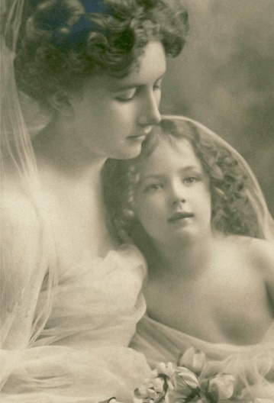

Para que me conozcas
Te protegeré hasta que hayas crecido y, entonces, seguiré protegiéndote.

Recuerdos de mi madre y de mi padre
(tu abuela y tu abuelo)
_______________________________________________________________________________________________________________________________________________________________________________________________________________________________________________________________________________________________________________________________________________________________________________________________________________________________________________________________________________________________________________________________________________________________________________________________________________________________________________________________________________
Cómo llamabas al abuelo y a la abuela____________________________________________
_______________________________________________________________________________
Nadie puede hacer por los niños lo que hacen sus abuelos...
pues los abuelos son aquellos que rocían polvos de estrella sobre la vida de los niños pequeños.
Alex Haley
FOTOGRAFIAS DE LA FAMILIA
Tú eres el espejo de la madre, y ella está en ti...
William Shakespeare
MIS COMIENZOS
Mi recuerdo más antiguo
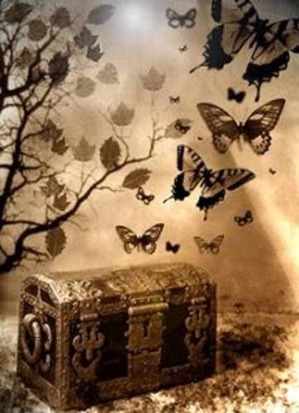
___________________________________________________________________________________________________________________________________________________________________________________________________________________________________________________________________________________________________________________________________________________________________________________________________________________________________________________________________
___________________________________
___________________________________

Dónde crecí
_____________________________________________________________________________________________________________________________________________________________________________________________________________________________________________________________________________________________________________________________________________________________________________________________________________________________________________________________________________________________________________________________________________________________________________________________________________________________________________________________________________________________________________________________________________________________________________________________________________________________________________________________________________________________________________________________________________________________________________________________

CUANDO ERA NIÑA...

Los mejores recuerdos de mi niñez
­­­­­­­­­­­­­­­­_______________________________________________________________________________________________________________________________________________________________________________________________________________________________________________________________________________________________________________________________________________________________________________________________________________________________________________________________________________________________________________________________________________________________________________________________________________________________________________________________________________________________________________________________________________________________________________________________________________________________________________________________________________________________________________________________________________________________________________________________________________________________________________________________________

___Los libros y otras cosas que amaba
_____________________________________________________________________________________________________________________________________________________________________________________________________________________________________________________________________________________________________________________________________________________________________________________________________________________________________________________________________________________________________________________________________________________________________________________________________________________________________________________________________________________________________________________________________________________________________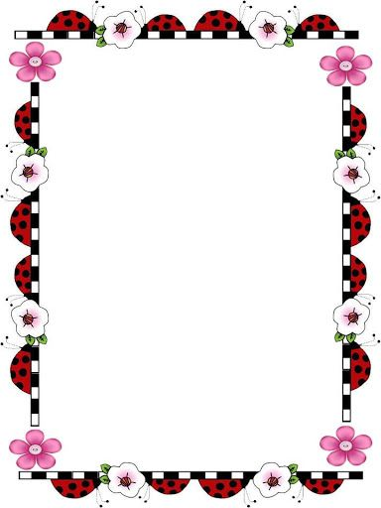
fotografía
FOTOGRAFÍAS

MIS DÍAS ESCOLARES
Mi primera escuela_______________________________________________________________________
______________________________________________________________________________________________
Mi primera amiga en la escuela_______________________________________________________
______________________________________________________________________________________________
Cómo iba a la escuela___________________________________________________________________
____________________________________________________________________________________________________________________________________________________________________________________________
Cómo era yo en esa época_____________________________________________________________
_________________________________________________________________________________________________________________________________________________________________________________________________________________________________________________________________________________________

FOTOGRAFÍAS
A LA HORA DE JUGAR
Mi juguete avorito_______________________________________________________________________
______________________________________________________________________________________________
Mi muñeca favorita______________________________________________________________________
Mis sueños_________________________________________________________________________________
________________________________________________________________________________________________
Mis amigos________________________________________________________________________________
______________________________________________________________________________________________
Juegos y pasatiempos que recuerdo____________________________________________________
________________________________________________________________________________________________
DÓNDE VIVÍA
Mi casa
_____________________________________________________________________________________________________________________________________________________________________________________________________________________________________________________________________________________________________________________________________________________________________________________________________________________________________________________________________________________
fotografía

MI CUARTO
Lo que más recuerdo de mi cuarto de pequeña...
__________________________________________________________________________________________________________________________________________________________________________________________________________________________________________________________________________________________________________________________________________________________________________________________________________________________________________________________________________________________________________________________________________________________________________________________________________________________________________________________________________________________________

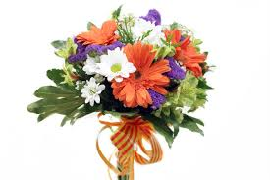
MIS MASCOTAS

FOTOGRAFÍA
Sus nombres________________________________________________________________________
____________________________________________________________________________

MIS AÑOS ADOLESCENTES
________________________________________________________________________________________________________________________________________________________________________________________________________________________________________________________________________________________________________________________________________________________________________________________________________________________________________________________________________________________________________________________________________________________________________________________________________________________________________________________________________________________________________________________________________________________________________________________________________________________________________________________________________________________________________________________________________________________________________________________________________________________________________________________________________________________________________________________________________________________

Enamoramiento
______________________________________________________________________________________________________________________________________________________________________________________________________________________________________________________________________________________________________________________________________________________________________________________________________________________________________________________________________________________________________________________________________________________________________________________________________________________________________________________________
Qué aprendí que quisiera decirte
_____________________________________________________________________________________________________________________________________________________________________________________________________________________________________________________________________________________________________________________________________________________________________________________________________________________________________________________________________________________________________________________________________________________________________________________

