Memorias de un padre
para su hijo(a)

“Este es mi legado para ti,
Con mucho amor
Tu papi”

Para:____________________________________________
con amor de: _____________________________________________

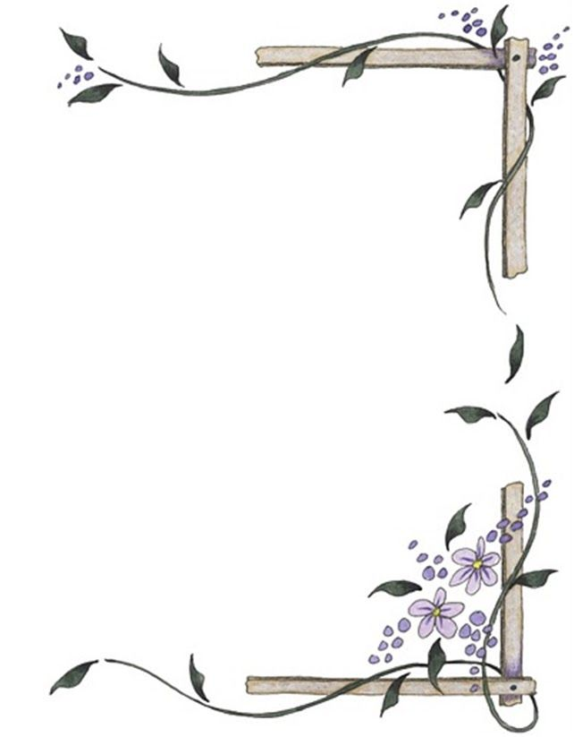

Por qué este libro es para ti, hijo(a)
______________________________________________________________________________________________________________________________________________________________________________________________________________________________________________________________________________________________________________________________________________________________________________________________________________________________________________________________________________________________________________________________________________________________________________________________________________________________________________________________________________________________________________________________________________________________________________________________________________________________________________________________________________________________________________________________________________________________________________________________________________________________________________________________________________________________________________________________________________________________________________________________________________________________________________________________________________

Un poco sobre mí, tu padre...

Mis nombres__________________________________________________________________________

Fecha de nacimiento_____________________________________________________

Lugar de nacimiento_____________________________________________________

Signo Zodiacal__________________________________

Hijo mío, nunca olvides que te amo. La vida está llena de momentos difíciles y de momentos bellos. Aprende de todo lo que puedas de ambos y usa tus experiencias para convertirte en un ser honesto, justo y amoroso. .
THEODOR REIK

Para que me conozcas

Te protegeré hasta que hayas crecido y, entonces, seguiré protegiéndote.

Recuerdos de mi madre y de mi padre
(tu abuela y tu abuelo)
_______________________________________________________________________________________________________________________________________________________________________________________________________________________________________________________________________________________________________________________________________________________________________________________________________________________________________________________________________________________________________________________________________________________________________________________________________________________________________________________________________________
Cómo llamabas al abuelo y a la abuela____________________________________________
_______________________________________________________________________________
Nadie puede hacer por los niños lo que hacen sus abuelos...
pues los abuelos son aquellos que rocían polvos de estrella sobre la vida de los niños pequeños.
Alex Haley
FOTOGRAFIAS DE LA FAMILIA

Tú eres el espejo de tu padre, y él está en ti...
William Shakespeare
MIS COMIENZOS
Mi recuerdo más antiguo
_____________________________________________________________________________________________________________________________________________________________________________________________________________________________________________________________________________________________________________________________________________________________________
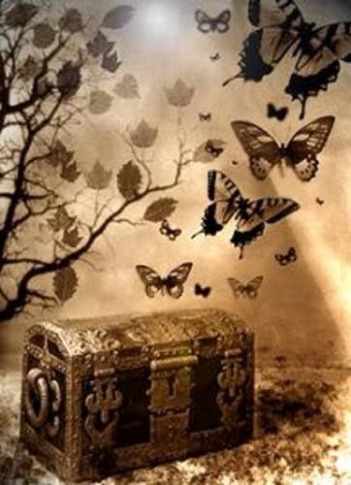
Dónde crecí
__________________________________________________________________________________________________________________________________________________________________________________________________________________________________________________________________________________________________________________________________________________________________________________________________________________________________________________________________________________________________________________________________________________________________________________________________________________________________________________________________________________

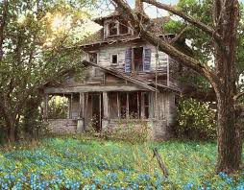

CUANDO ERA NIÑO...

Los mejores recuerdos de mi niñez
________________________________________________________________________________________________________________________________________________________________________________________________________________________________________________________________________________________________________________________________________________________________________________________________________________________________________________________________________________________________________________________________________________________________________________________________________________________________________________________________________________________________________________________________________________________________________________________________________________________________________________________________________________________________

Los y otras cosas que amaba________________________________________________________________________________________________________________________________________________________________________________________________________________________________________________________________________________________________________________________________________________________________________________________________________________________________________________________________________________________________________

FOTOGRAFÍAS

MIS DÍAS ESCOLARES
Mi primera escuela_______________________________________________________________________
______________________________________________________________________________________________
Mi primera amiga en la escuela_______________________________________________________
______________________________________________________________________________________________
Cómo iba a la escuela___________________________________________________________________
____________________________________________________________________________________________________________________________________________________________________________________________
Cómo era yo en esa época_____________________________________________________________
_________________________________________________________________________________________________________________________________________________________________________________________________________________________________________________________________________________________

FOTOGRAFÍAS

A LA HORA DE JUGAR

Mi juguete avorito_______________________________________________________________________
______________________________________________________________________________________________
Mis sueños_________________________________________________________________________________
____________________________________________________________________________________________________________________________________________________________________________________________
Mis amigos________________________________________________________________________________
______________________________________________________________________________________________
Juegos y pasatiempos que recuerdo__________________________________________________
_________________________________________________________________________________________________________________________________________________________________________________________________________________________________________________________________________________________

DÓNDE VIVÍA
Mi casa
_____________________________________________________________________________________________________________________________________________________________________________________________________________________________________________________________________________________________________________________________________________________________________________________________________________________________________________________________________________________
fotografía

MI CUARTO
Lo que más recuerdo de mi cuarto de pequeño...
___________________________________________________________________________________________________________________________________________________________________________________________________________________________________________________________________________________________________________________________________________________________________________________________________________________________________________________________________________________

MIS MASCOTAS

FOTOGRAFÍA
Sus nombres________________________________________________________________________
____________________________________________________________________________

MIS AÑOS ADOLESCENTES
________________________________________________________________________________________________________________________________________________________________________________________________________________________________________________________________________________________________________________________________________________________________________________________________________________________________________________________________________________________________________________________________________________________________________________________________________________________________________________________________________________________________________________________________________________________________________________________________________________________________________________________________________________________________________________________________________________________________________________________________________________________________________________________________________________________________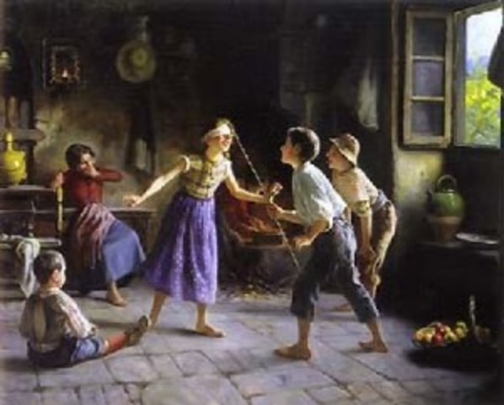
__________
____

__________________________________________________________
Enamoramiento
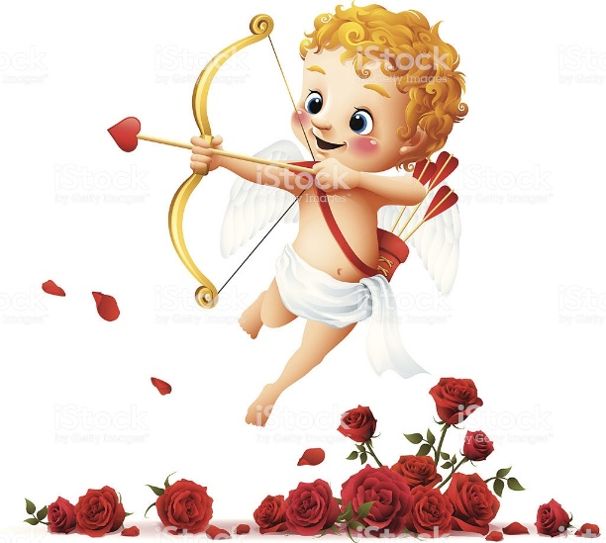
______________________________________________________________________________________________________________________________________________________________________________________________________________________________________________________________________________________________________________________________________________________________________________________________________________________________________________________________________________________________________________________________________________________________________________________________________________________________________________________________
Qué aprendí que quisiera decirte
________________________________________________________________________________________________________________________________________________________________________________________________________________________________________________________________________________________________________________________________________________________________________________________________________________________________________________________________________________________________

